

UNIVERSITY OF ST. GALLEN

Bachelor Thesis

Enhancing Corporate Valuations:
Predicting Long-Term Free Cash Flow Growth Rates
Using Machine Learning

Submitted by:
Jan Nemeth
23-614-118

Approved on Application by

Professor:
Dr. Despoina Makariou

Date of Submission:
17/11/2026

ABSTRACT
This thesis aims to analyse the potential that machine learning can bring in forecasting free cash flow growth rates, a parameter of substantial importance for DCF valuations which is often forecast inaccurately by analyst assumptions. To test this, supervised machine learning models are trained using a US-firm dataset.

Keywords: machine learning, free cash flow growth, DCF valuation, asset pricing

Table of Contents

List of Abbreviations 2
List of Figures 2
List of Tables 2
1 Introduction 3
2 Theoretical Foundations 5
2.1 Convergence Processes 5
2.2 Empirical Studies 6
2.3 Hypotheses 6
3 ML-Models & Quantitative Framework 7
3.1 Target Variable 7
3.2 Growth Rate Framework 7
3.3 Learning Function 9
3.4 Machine Learning Algorithms 9
3.5 Evaluation Criteria 9
4 Data 11
4.1 Description & Design Decisions 11
4.2 Feature Selection & Engineering 12
4.3 Data Analysis 13
4.3.1 Survivorship Bias 13
4.3.2 Mean Reversion in Growth Rates 14
5 Study 1 16
5.1 Methodology 16
5.2 Results 16
5.3 Robustness 16
References 16
Appendix (optional) 17
Declaration of Authorship 17
Declaration of Confidentiality (as applicable) 17

List of Abbreviations
LTGa … Refers to the Forecasts made by Analyst obtained from the I/B/E/S dataset 3-5 year horizon
LTG … Refers to the Long-Term Growth Rates of the core target variables in this empirical study
EBITDA:
FCF
ML

List of Figures

List of Tables

Introduction
The long-term growth assumptions of firm fundamentals are of the utmost importance in most corporate valuation models. For instance, the Discounted Cash Flow (DCF) model is used as the primary method in over 80% of corporate valuations, but it is significantly influenced by long-term free cash flow (FCF) growth projections in the terminal value component, making it susceptible to valuation errors (Mukhlynina & Nyborg, 2020, p. 209; Tengulov et al., 2025, p. 2122). In particular, the constant perpetual growth assumption after an explicit forecasting stage is often criticised, as this assumes that a company has reached its potential and will grow at the same rate as the overall economy (Tengulov et al., 2025 p. ). Recent research has even suggested that the terminal value idea should be eliminated in favour of explicit long-run forecasting, which would enable slower convergence processes to be modelled. (Cornell & Gerger, 2020, p.). Furthermore, crucial valuation multiples that are often considered complementary to classical DCF approaches, such as the price-to-earnings growth ratio, also require long-term growth projections (Gao & Wu, 2014, p.).
Because of the aforementioned importance analysts spend a significant amount of time forecasting long-term growth rates (LTGa), in particular earnings growth, since it has been empirically shown that investors care about these rates, as stock recommendations by analysts who incorporate LTGa forecasts imply a greater market reaction than those without (Jung et al., 2012, p.) Nevertheless, various studies have shown that LTGa projections are overly optimistic and that naive time series forecasts outperform analysts (Chan et al., 2003, p.; Albrecht et al., 1977, p.). Even more strikingly, LTGa from the I/B/E/S dataset, the most widely used proxy variable in prior research for long-run growth, covers a narrow horizon of 3–5 years and is, on average, 10% too optimistic compared to realized perpetual growth. Furthermore, it only weakly correlates with the latter, with 69% of analyst heterogeneity in LTGa projections for a given firm stemming from individual analyst characteristics rather than firm characteristics (Décaire & Guenzel, 2026, p.).
The ineffectiveness of LTGa forecasts has direct financial market implications. La Porta (1996, p.) demonstrates that a portfolio consisting of long positions in the bottom decile and short positions in the top decile of stocks of LTGa projections achieves excess returns after controlling for traditional factor models. While these results have been rejected upon replication, recent research has emerged that show LTGa estimates incorporate systematic overreactions to recent news extrapolated to long-term forecasts, yielding results similar to those found by La Porta (Hou et al., 2020, p.; Bordalo et al., 2024, p.).
It is evident from this discussion that a new LTG forecast measurement is needed, which should go beyond the typical 3–5-year horizon, expanding the explicit forecasting capability of corporate valuation models. Additionally, it should not suffer from the disadvantages of LTGa projections discussed above. Therefore, this thesis aims to provide growth projections on a longer-term basis, from year 5 to year 10. This starts directly where the most common explicit forecast (5 years) currently ends, delivering a second stage forecast in corporate valuation models before jumping to terminal value projections on a slower convergence process (Mukhlynina & Nyborg, 2020, p.).
To establish such a new growth rate forecast this research draws on a set of supervised machine learning (ML) algorithms, that will be concretely specified in Chapter 3. ML is suitable for this task because the combination of flexible functional relationships and regularisation, which makes it possible to test a rich set of features proposed by the existing literature, as well as learning predictor interactions and accounting for nonlinearity (Gu et al., 2020, p.). Furthermore, some ML methods, such as Random Forest, are particularly robust to outliers, which is important for long-term growth, since some firms are capable of growing at exceptionally high rates over a long period (Makariou et al., 2021, p.).
Additionally, these methods have recently gained popularity in the field of financial academia. Specifically, Gu et al. (2020, pp. 2250–2252) paved the way for the application of machine learning (ML) in finance by demonstrating that the R² value for predicting the returns of US equities can be improved using neural networks. Similarly, Chen et al. (2023) built upon this work by embedding ML into economic theory (stochastic discount factors) before estimating return predictions, thereby beating the benchmarks set by Gu et al. This thesis follows a similar approach. Rather than forecasting corporate valuations directly via ML, as Lu et al. (2025) and Vayas-Ortega et al. (2020) have studied, this research emphasises the importance of economic modelling by providing ML-enhanced input (long-run growth forecasts), rather than bypassing the corporate valuation exercise completely. Thus, this thesis asks the following question:
To what extent can ML-based models enhance the accuracy of long-term growth forecasts for US-listed firms, relative to traditional DCF assumptions, using accounting, market and analyst data?
Specifically, four contributions are made to the existing literature on long-term growth: First, this thesis introduces a set of nonlinear machine learning methods, whereas current research primarily evolves around linear regressions (Gao & Wu, 2014; Chan, 2003; Kryzanowski & Mohsni, 2012; Tengulov et al. 2025). Secondly, by involving supervised ML techniques, the core aim of the thesis is prediction, not explanation (Shuemli, 2010). Nevertheless, classical feature analysis tools such as minimal depth and permutation importance will be discussed. Thirdly, this thesis aims to assess long-term growth by explicitly skipping short-run growth up to t+5. Diverging from existing LTG literature, e.g. Tenugolov, 2025, who does not explicitly exclude the short-term forecast horizon, which means their promising results could be explained by good short-term behaviour rather than long-term performance. Fourthly, building on La Porta (1996), a portfolio of LTG projected stocks will be tested. However, rather than market-expected growth rates, it is the predicted growth rates that form the core decision-making mechanism behind this portfolio. Chapter 2 will discuss the theoretical setting, while Chapter 3 presents target variable and the concrete quantitative models that form the basis for the empirical section. Chapter 4 will present the concrete ML tasks, the data behind them, the methodology used and the results. Chapter 5 examines concrete portfolio settings, building on predicted growth rates. Finally, Chapter 6 concludes with a general discussion about the academic and practical relevance of the underlying results.

Theoretical Foundations
This chapter derives the economic theory of long-term firm growth rates. First, it presents arguments as to why long-run growth rates should converge to equilibrium levels (Chapter 2.1.1), and goes on to present empirical studies of long-term growth rates (Chapter 2.2). After laying the theoretical groundwork, two hypotheses for this thesis are derived in Chapter 2.3.

Convergence Processes
The literature on firm growth was introduced by Robert Gibrat in the 1930s with the famous Gibrat Law which states that the growth of a firm is independent of its size (Sutton, 1997, p.). Thus, the Gibrat Law implies that no individual firm characteristics or industry variables can predict a firm's growth outcomes. Therefore, applying the same growth rate to all firms would be reasonable, and no firm's fundamental growth prediction exercises would make sense. However, Gibrat's results were empirically rejected, with findings showing that firm-, size- and age-variables, included in Chapter 4, play crucial roles in firm growth rate predictions (Sutton, 1997, p.).
Besides size and age, further studies have shown that earnings growth is to some extent predictable due to profitability convergence (Fama & French, 2000). The reasoning behind this is deeply rooted in economic theory, with highly profitable firms facing margin pressure from new competitors, leading to a decline in profitability towards a competitive equilibirum, which in turn implies earnings convergence. Fama and French (2000, p.) demonstrated that this effect leads to an average profitability convergence of 38% per year, with affects being nonlinear when profitability levels being highly above or below equilibrium levels. This means that, in five years on average, only around 10 per cent of excess profitability remains, which has predictable convergence effects on earnings. While this is a strong argument for the most common 5-year forecasting stage, assuming perpetual equilibrium growth thereafter, other studies have shown that convergence is less evident when controlling for characteristics like the firm life cycle (Dickinson, 2011, p.). For instance, it was shown by Dickinson (2011, p.) that profitability differences remain persistent over three times in magnitude between mature and declining firms after five years, a period during which only marginal profitability differences were predicted to remain by Fama and French.
As an argument to justify perpetual growth after ten years, which would follow the explicit long-term growth prediction horizon of the thesis, Chan et al. (2003, p.) examined the historical earnings growth rates of US companies from 1951 to 1998. They demonstrated that only 0.2% of firms have an above-median earnings growth rate for ten consecutive years, roughly matching the expected random result of 0.1%. Therefore, strong convergence arguments are implied for a 10-year horizon.
In conclusion, the theory states that earnings convergence exists, but is deeply rooted in profitability convergence. The latter is non-linear and depends on important firm characteristics, such as the stage of the firm's life cycle. The aim of the empirical models in Chapter 4 is to capture these conditions.

Empirical Studies
If long-run growth is partly predictable, two empirical questions follow: whether statistical models can translate this predictability into accurate firm-level forecasts, and whether such forecasts matter for asset prices (Claude, 2026).
Most relevant to the first question are the findings of Tengulov et al. (2025, p.), who used traditional and regularised linear regressions to predict the geometric growth rates of EBITDA and sales as a proxy for FCF over a five- and ten-year horizons. This was achieved using a rich set of features of firm characterstics, industry and macro variables that will be discussed in detail in Chapter 4.1.2. They demonstrated that linear regressions could explain approximately 22% of variation in long-term revenue growth (Tengulov et al., 2025, pp. 2146–2147). If the Fama-French results on nonlinear earnings convergence are valid, nonlinear ML models should improve upon the linear regression results of Tengulov et al. Thus, the former's models provide a benchmark for the ML-models employed in this thesis.
Regarding the influence on asset prices, the empirical portfolio formation of long-run growth rates has been studied in earlier papers. La Porta's (1996, p.) long-short portfolio of LTG I/B/E/S analyst forecasts was built on the idea that high LTG forecasted stocks are overly optimistic and, as a result, should be overpriced (going short in the highest decile), and vice versa. He did indeed find excess returns, but these failed to be replicated by Hou et al. (2020, p.). Nevertheless, La Porta's methodological insights are still important. For instance, Chapter 6 constructs a portfolio based on yearly rebalancing and the same long-short decile sorts suggested by La Porta in his paper. The crucial difference is that decile sorting is based on predicted growth rates rather than market-expected analyst growth rates.

Hypotheses
Building upon the theoretical foundations I derive the following hypotheses:
H1: Supervised ML-models outperform linear regressions in terms of prediction accuracy for long-term growth predictions.
H2: A portfolio consisting of long positions in the top- and short positions in the bottom decile of predicted long-term growth stocks achieves excess returns after accounting for traditional factor models.
To test both hypotheses, a quantitative study design is needed, incorporating correctly specified ML models, a clear dataset with reasonable target variables and features, and clear prediction measures. Achieving this is the goal of the following two chapters.

ML-Models & Quantitative Framework

Target Variable
As stated in Chapter 1, since most corporate valuation models are closely linked to FCF growth, it is evident that this accounting figure is the primary focus of this research. In this thesis FCF is defined as follows:
$$Free Cash Flow = Cash Flow from Operations – Capital Expenditures$$

However, the problem with FCF is that it is a highly volatile value which can be negative. The later makes it impossible to calculate geometric growth rates, resulting in many observations missing a target variable that cannot be used for prediction (Tengulov et al., 2025, p.). Following the empirical design of Tengulov et al. (2025), this thesis uses revenue and EBITDA as additional target variables alongside FCF, since both figures are closely linked to the former and have fewer negative values. To undermine this argument, EBITDA and revenue have a Pearson correlation coefficient of 0.86 and 0.61 with FCF in the underlying dataset, respectively.

Growth Rate Framework
The aim of this thesis is to estimate three target variables, as outlined in Chapter 3.1. Specifically, F corresponds to the target variable in question, with $F∈\left\{FCF, EBITDA, Revenue\right\}$. Similarly to existing literature, this thesis will focus on the annualised geometric growth rate since a core advantage of these is that they only require two data points and are therefore highly efficient for growth calculations (Tengulov et al., 2025, p. X). The formula for the annual geometric growth rate of company i in year t is given by the following equation:
$$g_{CAGR i,t}^{\left(a,b^{*}\right)}={\left(\frac{F_{i,t+b^{*}}}{F_{i,t+a}}\right)}^{\frac{1}{b^{*}-a}}-1$$

$$with F_{i,t+a }>0 ∧{ F}_{i,t+b^{*}} >0 and b^{*}=b in the normal case discussed below.$$
Where $\left(a,b\right)$ represents the previously stated target windows with $\left(a,b\right) ∈ \left\{\left(5,10\right)\right\}$ and $t$represents a fixed yearly value per row. This strict definition of the target window has methodological consequences. Specifically, for the $\left(5,10\right)$ horizon, if $t+b$ is not available in the data, for instance if $t= 2017 → t+10 = 2027$ which lies in the future and cannot be observed, the growth rate would be missing. To avoid missing data and to be able to use more recent observations, even if $t+b$cannot be observed, the following fallback decision was used:

$$b^{*}=\min\left(b ;T_{\text{last}}-t\right)with{ T}_{\text{last}}=2025, s.t.{ b}^{*}≥b_{min}$$

Where $b_{min}$ was set to 8. This expands the observed target window set to $\left(a,b\right) ∈ \left\{\left(5,8\right),\left(5,9\right),\left(5,10\right)\right\}.$ One limitation of this approach is that some annual growth rates are calculated over shorter periods than others, but this allows this thesis to consider observations up to 2017. According to the data, over 82% of observations still have the predefined horizons of $\left(5,10\right)$. To clarify the construction, Figure 2 provides a specific example from the dataset:
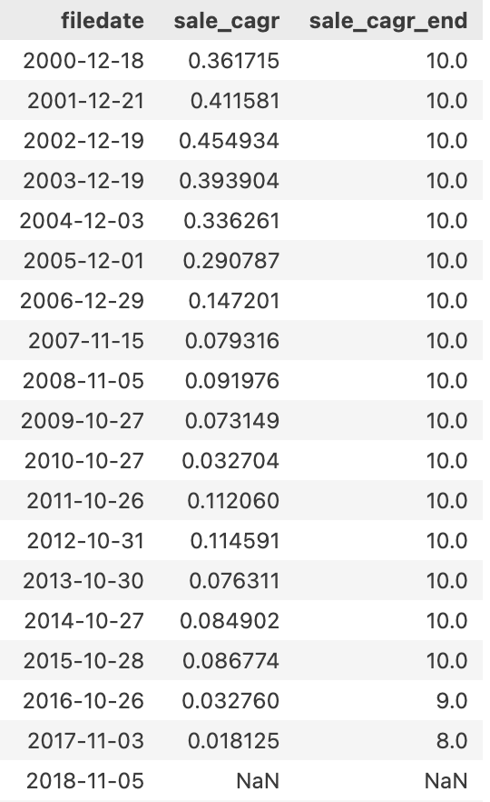
Figure 2
Figure 2 shows the annualised geometric growth rates calculated for F = revenue. Until $t+b ≤ 2025$ a 5 to 10 Year Horizon is applied for growth calculations. From 2016 onwards, the fallback decision takes effect and the 5- to 9-year and 5- to 8-year horizons are used for the next two observations. From 2018 onwards, no calculations can be made since $b^{*}=7→b^{*}<b_{min}$.
Using the conventional definition of annualised geometric growth rates is not without criticism. Gao and Wu (2014, p. 74) emphasise that the former may not accurately reflect the underlying time horizon when the desired growth rate variable is highly volatile, as is the case with the accounting variables studied in this thesis. This can be mitigated by using a least squares growth rate that takes account of all data points, which will be used as an additional measure of growth to increase the robustness of this thesis (2014, pp. 74–75). The procedure is as follows: First, a valid set, $T_{i,t}$ for each firm-year pair (i,t) must be defined. This includes all values where $τ$ is a particular year in the previously discussed horizon $(a,b)$ and $F_{i,t+τ} > 0$, stated more formally:
$$T_{i,t}=\{τ∈\{a,…,b\} :F_{i,t+τ}>0\}$$
Then, an OLS regression line is fitted in the following way:
$$\ln{F_{i,t+τ}=α_{i,t}+g_{i,t}*τ+ε_{i,t+τ} ,τ∈T_{i,t} }$$
The fitted growth coefficient can be obtained by the well-known OLS coefficient solution (Source):
$$\hat{g_{i,t}}=\frac{\sum_{τ∈T_{i,t}}{\left(τ - \overline{τ}\right)\left(ln F_{i,t+τ}-\overline{ln F}\right)}}{\sum_{τ∈T_{i,t}}{{\left(τ- \overline{τ}\right)}^{2}}}.$$
Where $\overline{τ} and \overline{ln F} are means.$The growth rate is missing when the maximum year in the valid set is smaller than the minimum value $τ_{min}$of the fallback mechanism, which is again set to 8 and 18 years, respectively. Since the LSQ approach considers each observation within the time horizon, a minimum of n = 4 must be included in the valid set. Finally, since the fitted growth rate is fitted to the logarithmic target variable, it must be converted back to be compared to the annualised geometric growth rate,$g_{LSQ i,t} exp\left(\hat{g_{i,t}}\right)-1$.
Furthermore, an additional growth rate dataset (CAGR & LSQ) for all the variables in F, across t+10 horizon, that does not skip the explicit forecast stage is used to ensure direct comparability with Tengulov et al., 2025.

Learning Function
This research assumes that the functional relationship $f$between a target variable $y_{i,t}$ and a feature vector $x_{i,t }$= ($x_{1i,t }, x_{2i,t} ,..., x_{ki,t })$with k features for an observation $i in year t$is given by: $y_{i,t}=f\left(x_{i,t}\right)+ν_{i,t}$, where $ν_{i,t}$ corresponds to an random error term that is distributed around (Makariou, 2024, p. 23). Specific, to this setting $y_{i,t}$ corresponds to the long-run growth rate while $x_{i,t}$denotes a vector of various characteristics for a firm i in year t discussed in Chapter 4.2. However, the true functional relationship $f$ is unknown. The core goal of the ML-Models presented in the next Chapter is deriving an estimation of the functional relationship $\hat{f}$, that helps to estimate long run growth $\hat{y_{i,t}}$with the underlying feature vector$, concretely$ $\hat{y_{i,t}} = \hat{f}(x_{i,t })$ ((Makariou, 2024, pp. 23–26). How good the estimation procedure works will be determined by a set of rules in the Chapter 3.5.

Machine Learning Algorithms
Open: Abschlussatz: How good the the estimation procedure works will be determined by a set of rules in the Chapter 3.4.

Evaluation Criteria
There are various performance metrics for prediction settings, each with their own advantages and disadvantages, and the most appropriate one depends heavily on the underlying task (Hyndman & Koehler, 2006, p.). This thesis focuses on minimising mean squared error (MSE) as it is one of the three most common evaluation criteria and has the advantage of penalising large deviations, which is desirable in this research since large growth rate errors will have profound valuation consequences (Botchkarev, 2018, pp. 4–12). To avoid overfitting of the ML models, the MSE used as the assessment criterion is the MSE calculated on the unseen test set. Meanwhile, the MSE on the training set is minimised, a topic that will be discussed further in Chapter 4.1 (Chassot, 2024, pp. 17–18). The formula for the MSE on the test set is:
$$MSE_{test}=\frac{1}{n}\sum_{\left(i,t\right)}{{\left(g_{i,t}-\hat{g_{i,t}}\right)}^{2}}$$
Where $g_{i,t}$denotes the LTG rate in the test set and $\hat{g_{i,t}}$ the predicted LTG rate for a firm i in year t, the squared error is averaged over all firm-year observations n in the test set.
Furthermore, since most previous empirical studies judge model performance using out-of-sample R², this measure, which is deeply tied to MSE, will be reported and discussed alongside MSE. Following a similar definition of Campbell & Thompson (2007, p. X) it is defined as:
$$R_{OOS}^{2}=1-\frac{\frac{1}{n}\sum_{\left(i,t\right)}{{\left(g_{i,t}-\hat{g_{i,t}}\right)}^{2}}}{\frac{1}{n}\sum_{\left(i,t\right)}{{\left(g_{i,t}-\overline{g}\right)}^{2}}}$$
Here, $\overline{g}$refers to the mean of growth rate in the training set. When $R_{OOS}^{2}$ is positive, this means that the MSE of the ML model is lower than the MSE of the mean of the training set (Campbell & Thompson, 2007, p. X).

Data

Description & Design Decisions
Firm fundamental data, for active and inactive firms is obtained by Compustat, market return data by CRSP (adjusted for survivorship bias by incorporating delisting returns), and analyst forecasts by LSEG I/B/E/S, which is accessed via Wharton Data Research Services (WRDS) and covers a range from 1987-2025. Moreover, macroeconomic data over the same horizon was obtained from EDGAR.
Combining these various data sources is challenging since the databases use different company identifiers (e.g. gvkey [Compustat], permno [CRSP]) and merging based on the stock ticker is not an option since tickers can change over time and may be used by different companies (WRDS So). Fortunately, WRDS provides linking tables that simplify merging, which were used in dataset construction with the constraint that only firm-year observations were kept for which the linkage was verified as of reasonable quality. This is the first source of data bias, as potentially well-recognised firms are more likely to have verified linkages between the databases. <One sentence estimation how big effect in Notebook>.
Secondly, a crucial point is data time leakage, whereby information used in forecasting is unavailable at the time of prediction (Shmueli, 2010). In this thesis, one potential source of time leakage is that accounting data is not available on the last day of the fiscal year, but later when the annual report is made public. This would lead to forecasts at the end of a fiscal year being affected by time leakage. To prevent this, the filing date of annual reports can be obtained from an additional Compustat database, leading to the following decision rule of this thesis: Each prediction will be made on the date the report was filed, meaning all other features (e.g. market returns and analyst forecasts) must be known before the filing date.
A third potential source of data bias is that missing values are rarely entirely random (Sallin, 2025, p. 31). For example, only half of the companies in the Compustat dataset have consistent LTG analyst coverage. Simply dropping half of the observations without this coverage would not only shrink the dataset, but would also cover a different sample of firms, biased towards larger ones. This can be seen in the difference in median market value between the dataset with and without analyst expectations, which is roughly three times the size. To mitigate this issue, both types of datasets will be used for modelling. This crucial difference can be exploited to gain insight by comparing a smaller, large-cap-driven dataset, including X observations with better coverage to a larger dataset, including Y observations with more representative firms and no analyst coverage as shown in Table X.
Fourth, due to the aim of observing LTG rates, survivorship bias is unavoidably induced because we can only observe firms that have survived the corresponding time periods. Naturally, the most recent observations are from 2017 and 2007 respectively, as specified in Chapter 3.2 (Chan et al., 2003; Tengulov et al., 2025). Consequently, as shown in Table X, the number of firm-year observations drops significantly for each dataset. For instance, whereas the full dataset comprises X observations, there are merely X firm-year pairs with a t+5, t+10 EBITDA growth rate. The situation is even more extreme for the longer-horizon dataset.

 |  |  |  |  | Target Variables
Dataset | Features | Full Obs. | Firms | Estimator | FCFF | EBITDA | Sales
With I/B/E/S | Firm, Industry, Macro & Analyst | 57.359 | 7.564 | CAGR | 19.006 | 27.695 | 31.976
 |  |  |  | LSQ | 22.234 | 28.989 | 32.084
Without I/B/E/S | Firm, Industry, Macro | 124.330 | 13.220 | CAGR | 30.088 | 45.794 | 59.444
 |  |  |  | LSQ | 35.771 | 49.038 | 59.923

Table 2: Dataset Description

Feature Selection & Engineering
The feature selection in this thesis is firmly rooted in existing academic research and economic theory. However, one cannot ignore features that have been shown to be insignificant in earlier studies, since most of these focused on linear regressions and the features in question may exhibit nonlinear effects or stand out due to their importance in predictor interactions for ML- models, as explained in Chapter 1.
As shown in Figure X, features can be divided into eight blocks. For instance, to evaluate the time-series component of LTG, five-year prior growth rates in FCF, EBITDA and revenue are used, which Gao and Wu (2014, p. ) considered to be key predictors. In terms of valuation measures, dividend yield is a critical long-term component of various corporate valuation models (e.g. Gordon growth), alongside book-to-market and earnings-to-price features, which reflect market expectations about growth rates (Chan et al., 2003, p.; Tengulov, 2025, p.). Furthermore, according to Tengulov et al. (2025, p. 2127), firm investment decisions are closely linked to future FCF. Therefore, how much capital is used by the firm relative to its total assets (capital intensity), as well as how much of its earnings the firm pays out to shareholders rather than investing internally, play pivotal roles. However, in contrast to existing literature, more emphasis is also given to firm and industry profitability, e.g. return on equity, since this has important consequences for growth rate convergence, as discussed in Chapter 2.1.
Moreover, the lower survival probability of riskier companies naturally impacts future growth. That’s why the thesis includes a set of risk measures ranging from stock market risk (beta) to idiosyncratic firm risk and firm leverage (Gu et al., 2020, p. X; Tengulov et al., 2025, p. X). Additionally, as discussed in Chapter 2.1, a firm's life cycle state plays a key part in profitability convergence; this is why the former is approximated by cash flow patterns and firm age features. Lastly, firm-specific LTGa forecasts, which form the basis of previous academic studies, are also included to determine whether analysts use additional information that is not explained by other firm-specific feature groups, such as valuation or risk (La Porta 1996; Bordalo et al, 2023).
Since the industry is likely to play a crucial role in future growth rates, industry dummies, as well as variables that approximate market concentration within an industry, such as the Herfindahl index on sales, are included (Tengulov et al., 2025, p. X). Finally, macroeconomic variables well-grounded in previous studies are included to determine whether the aggregate economic state affects LTG rates. A full feature list and the specific feature calculation can be found in Figure 1 and Appendix X, respectively.

Data Analysis
This Chapter highlights the key findings of the Explorative Data Analysis, which can be found in detail in the Jupyter Notebook. Note that this Chapter uses the broader dataset without analyst coverage, because more observations are available.

Survivorship Bias
As discussed in Chapter 4.1, survivorship bias is an inherent issue in the research design. This section therefore aims to quantify the extent of the bias in the final dataset. This will be assessed by splitting the data into two categories where any target variable is available, and where all target variables are missing. The medians of important features will then be reported, as shown in Table X.

 | No target | Valid target | Ratio
Market Value | 146.36 | 570.32 | 3.90
Return on Asset | 0.26 | 4.66 | 18.19
Operating Margin | 6.76 | 13.14 | 1.94
Beta | 1.16 | 1.01 | 0.87
Idiosyncratic Vol. | 0.53 | 0.36 | 0.67
Debt to Assets | 19.78 | 22.75 | 1.15
Book to Market | 0.45 | 0.47 | 1.04
Sales to Price | 0.80 | 1.04 | 1.29

Table 3: Quantification of the Survivorship Bias

Notably, companies that have a target variable and are therefore available for predictive modelling are, on average, 18.19% more profitable, as measured by ROA, than companies that do not. This profitable divergence is not only a sign of caution, but it also partly justifies the importance of profitability in the theory developed in Chapter 2. Furthermore, data with target variables also exhibits significant size bias, incorporating companies that have a 3.90 times larger market value, and also shows moderate tendencies towards lower risk and higher valuations. Not reported in the table, but also of crucial relevance, is the divergence in proportion of active vs. inactive firms. When the target variable is available, the proportion of active firms is 57%, whereas this proportion drops to 30% when the target variable is unavailable. Lastly, regarding the firm life cycle, over 85% fall into the Maturity or Growth stage when the target variable is available, compared to 55% vice versa. In conclusion, the ML models developed in Chapter 5 are trained on a sample that leans towards larger, more profitable companies that are predominantly in the Maturity or Growth Firm Stage and are still active today. Therefore, the ML predictions should perform best for these types of companies.

Mean Reversion in Growth Rates
A core assumption of the underlying thesis is that machine learning (ML) models can provide valuable insights into company growth rates within the T+5 to T+10 timeframe. Consequently, terminal growth convergence does not occur within this window, but rather after 10 years.
To examine this, the data is grouped into five quintiles of cross-sectional past growth rates (t-5 to t), then the average target variable (t+5, t+10) is calculated for each quintile, as shown in Figure X
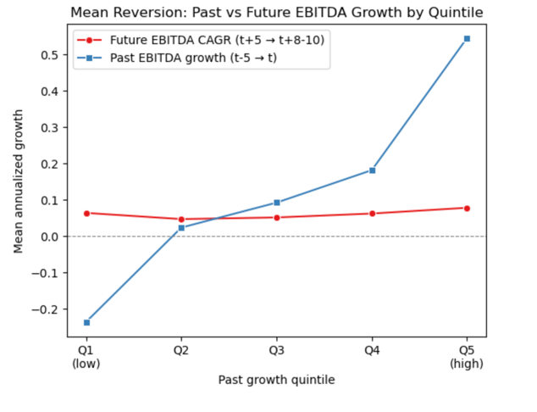

It can be observed that the red line, which represents future EBITDA growth, remains relatively flat across all past growth quintiles. This suggests that convergence may occur within the t+5 to t+10 timeframe, which would pose a significant challenge to the research. However, a more granular view, taking into account Life Cycle and Profitability Quintiles, which are crucial in economic theory regarding growth divergence as suggested by Dickinson (2011, p. ), shows a different picture. As Figure X demonstrates real growth divergence between the various life cycle and profitability groups persists for the t+5 to t+10 horizon. This further suggests that the ML models in Chapter 5 could extract relevant patterns from these features.

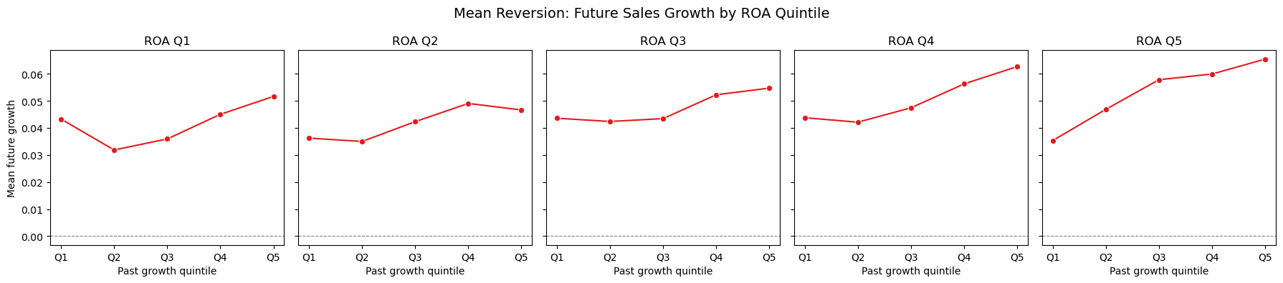
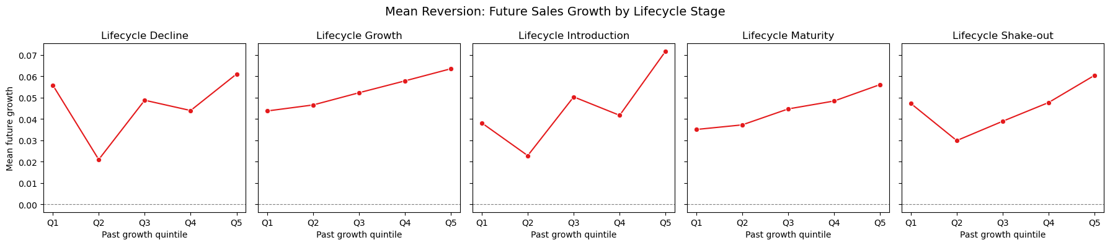

The mean-reversion effects in Figures X and X were tested for different time periods and for the entire time sample, and the results were similar in each period. It is crucial to have no time-varying tendency, since the number of US-listed firms has been declining structurally since the 1990s, resulting in fewer observations per year in the data and demonstrating that learning from older observations remains valuable today (Doidge et al., 2017).

Empirical Forecasting of Long-Term Growth Rates

Methodology
- Data Preprocessing which sets are tested, train / test splitting decision

Results

Robustness
- Feature Firm+Macro+Industry, Firm + Macro, Firm + Industry
- See if predictions are better for the categorie

References
Albrecht, W. S., Lookabill, L. L. & McKeown, J. C. (1977). The Time-Series Properties of Annual Earnings. Journal Of Accounting Research, 15(2), 226. https://doi.org/10.2307/2490350
Anthropic. (2026). Claude (Opus 4.7) [Large language model].
https://www.anthropic.com/claude
Bordalo, P., Gennaioli, N., La Porta, R., & Shleifer, A. (2023). Belief overreaction and stock market puzzles. Journal of Political Economy, 132(5), 1450–1484. https://doi.org/10.1086/727713
Botchkarev, A. (2018). Performance Metrics (Error Measures) in Machine Learning Regression, Forecasting and Prognostics: Properties and Typology. arXiv (Cornell University). https://doi.org/10.48550/arxiv.1809.03006
Campbell, J. Y. & Thompson, S. B. (2007). Predicting Excess Stock Returns Out of Sample: Can Anything Beat the Historical Average? Review Of Financial Studies, 21(4), 1509–1531. https://doi.org/10.1093/rfs/hhm055
Chan, L. K. C., Karceski, J. & Lakonishok, J. (2003). The Level and Persistence of Growth
Rates. The Journal of Finance, 58(2), 643–684. https://doi.org/10.1111/1540-
6261.00540
Chassot, J. (2024). Training, Validation, Testing. [PowerPoint Slides]. Canvas@HSG
Chen, L., Pelger, M., & Zhu, J. (2023). Deep learning in asset pricing. Management Science,
70(2), 714-750. https://doi.org/10.1287/mnsc.2023.4695
Cornell, B., & Gerger, R. (2020). Is it Time to Terminate the Traditional Terminal Value? SSRN Electronic Journal. https://doi.org/10.2139/ssrn.3739020
Décaire, P. H., & Guenzel, M. (2023). What drives very Long-Run Cash flow growth expectations? SSRN Electronic Journal. https://doi.org/10.2139/ssrn.4637198
Dickinson, V. (2011). Cash Flow Patterns as a Proxy for Firm Life Cycle. The Accounting Review, 86(6), 1969–1994. https://doi.org/10.2308/accr-10130
Fama, E. F. & French, K. R. (2000). Forecasting Profitability and Earnings. The Journal Of Business, 73(2), 161–175. https://doi.org/10.1086/209638
Gao, Z., & Wu, W. (2014). Predicting long-term earnings growth from multiple information sources. International Review of Financial Analysis, 32, 71–84. https://doi.org/10.1016/j.irfa.2014.01.009
Gu, S., Kelly, B., & Xiu, D. (2020). Empirical Asset Pricing via Machine Learning. Review
of Financial Studies, 33(5), 2223–2273. https://doi.org/10.1093/rfs/hhaa009
Hou, K., Xue, C. & Zhang, L. (2020). Replicating anomalies. https://econpapers.repec.org/RePEc:oup:rfinst:v:33:y:2020:i:5:p:2019-2133.
Hyndman, R. J. & Koehler, A. B. (2006). Another look at measures of forecast accuracy. International Journal Of Forecasting, 22(4), 679–688. https://doi.org/10.1016/j.ijforecast.2006.03.001
Jung, B., Shane, P. B., & Yang, Y. S. (2011). Do financial analysts’ long-term growth forecasts matter? Evidence from stock recommendations and career outcomes. Journal of Accounting and Economics, 53(1–2), 55–76. https://doi.org/10.1016/j.jacceco.2011.11.002
Kryzanowski, L. & Mohsni, S. (2012). Growth of aggregate corporate earnings and cash-flows: Persistence and determinants. International Review Of Economics & Finance, 25, 13–23. https://doi.org/10.1016/j.iref.2012.05.003
La Porta, R. (1996). Expectations and the Cross‐Section of stock returns. The Journal of Finance, 51(5), 1715–1742. https://doi.org/10.1111/j.1540-6261.1996.tb05223.x
Lu, T. & Zhao, Y. (2025). The Machine Learning-Enhanced DCF Model and Probabilistic Cash Flow Forecasting. Association For Computing Machinery, 126–133. https://doi.org/10.1145/3760023.3760045
Makariou, D. (2024). Basics of Machine Learning with examples in financial applications. [PowerPoint Slides]. Canvas@HSG
Makariou, D., Barrieu, P. & Chen, Y. (2021). A random forest based approach for predicting spreads in the primary catastrophe bond market. Insurance Mathematics And Economics, 101, 140–162. https://doi.org/10.1016/j.insmatheco.2021.07.003
Mukhlynina, L. & Nyborg, K. G. (2020). The Choice of Valuation Techniques in Practice:
Education Versus Profession. Critical Finance Review, 9(1–2), 201–
265.https://doi.org/10.1561/104.00000088
Sallin, A. (2025). Exploratory Data Analysis and Visualization, Part 1. [PowerPoint Slides]. Canvas@HSG
Shmueli, G. (2010). To Explain or to Predict? Statistical Science, 25(3). https://doi.org/10.1214/10-sts330
Sutton, J. (1997). Gibrat’s Legacy. Journal Of Economic Literature, 35(1), 40–59. https://www.jstor.org/stable/2729692
Tengulov, A., Zechner, J. & Zwiebel, J. (2025). Valuation and Long-Term Growth Expectations. Journal of Financial and Quantitative Analysis, 60(5), 2121–2158. https://doi.org/10.1017/s0022109024000425
Vayas-Ortega, G., Soguero-Ruiz, C., Rodríguez-Ibáñez, M., Rojo-Álvarez, J. & Gimeno-Blanes, F. (2020). On the Differential Analysis of Enterprise Valuation Methods as a Guideline for Unlisted Companies Assessment (II): Applying Machine-Learning Techniques for Unbiased Enterprise Value Assessment. Applied Sciences, 10(15), 5334. https://doi.org/10.3390/app10155334

Appendix (optional)

Declaration of Authorship

Declaration of Confidentiality (as applicable)

A key limitation of this definition is that it does not include interest expenses in the calculation of free cash flow. This is because there is a high level of missing data on interest expenses in the dataset presented in Chapter 4.

